**BLOCKCHAIN-BASED COUNTERFEIT MEDICINE AUTHENTICATION SYSTEM**

**ABSTRACT**

The escalation of counterfeit medicines within the global market poses a significant threat to public health, necessitating innovative technological interventions. We propose a cutting-edge web application that employs blockchain technology to assure the authenticity of pharmaceutical products. This application is uniquely designed to centralize control in the hands of drug administrators, who play a pivotal role in registering and managing all pertinent details related to medicines, manufacturers, and distributors on the blockchain. This approach not only streamlines the management process but also ensures a higher level of security and integrity within the pharmaceutical supply chain.

**Centralized Management by Drug Administrators**: The web application features a robust administrative portal through which drug administrators can add, update, and manage comprehensive details about medicines. This includes formula information, expiry dates, pricing, and the specifics of their respective manufacturers and distributors. By centralizing these functions, the application ensures that all information on the blockchain is verified and authorized, thereby preventing unauthorized modifications, and enhancing the reliability of the data.

**Blockchain Integration for Authentication**: At the core of the application is the blockchain technology that records every detail entered by the drug administrator, creating an immutable and transparent ledger. This ledger serves as the foundation for verifying the authenticity of medicines, enabling a secure and trustworthy verification process for end-users.

**Customer Verification Through QR Code Scanning**: Customers can authenticate their medicines by simply scanning a QR code on the medicine packaging. This QR code, generated and encrypted with all necessary medicine information by the drug administrator, when scanned, provides customers with instant access to the blockchain-recorded data. This data includes comprehensive details about the medicine's origin, manufacturing, and expiry dates, ensuring that customers receive genuine products.

**PROBLEM DEFINITION**

The global pharmaceutical industry faces a critical challenge in combating the pervasive issue of counterfeit medicines, which pose significant risks to public health and undermine trust in healthcare systems. Despite existing regulatory frameworks and traditional track-and-trace technologies, the current systems are plagued by vulnerabilities such as tampering, lack of transparency, data security risks, operational inefficiencies, and limited standardization across global markets. These limitations facilitate the entry of counterfeit drugs into the supply chain, making it difficult for stakeholders to verify product authenticity effectively. Consequently, there is an urgent need for an innovative solution that can address these challenges by enhancing the security, transparency, and traceability of pharmaceutical products, thereby ensuring the integrity of the supply chain and safeguarding patient safety.

**Detailed Problem Definition:**

**Public Health Risks**

Counterfeit medicines represent a grave threat to public health, with the potential to cause harm or even death. These fraudulent products may contain incorrect ingredients, improper dosages, or toxic substances. The prevalence of such medicines compromises the effectiveness of treatments, exacerbates health conditions, and leads to a loss of life, highlighting an urgent public health crisis that demands immediate and effective solutions.

**Erosion of Trust in Healthcare Systems**

The circulation of counterfeit medicines significantly undermines the trust that patients place in healthcare systems. When patients cannot be certain about the authenticity and safety of their medications, their confidence in healthcare providers, pharmacies, and the broader medical infrastructure erodes. This erosion of trust can lead to decreased adherence to medication regimens, reluctance to seek medical care, and a general skepticism towards healthcare advice and products.

**Vulnerabilities in Existing Systems**

Current measures to combat counterfeit medicines, including regulatory frameworks and track-and-trace technologies, suffer from critical vulnerabilities:

* **Tampering and Fraud**: The existing technologies, such as barcodes and RFID tags, can be duplicated or manipulated, allowing counterfeit drugs to infiltrate the legitimate supply chain undetected.
* **Lack of Transparency**: Centralized databases fail to provide comprehensive visibility to all stakeholders, obstructing the ability of consumers, healthcare providers, and regulatory bodies to independently verify the provenance and authenticity of pharmaceutical products.
* **Data Security Risks**: Centralized systems are prone to cyber-attacks and data breaches, which can compromise sensitive information about drug formulations, manufacturing processes, and distribution networks.
* **Operational Inefficiencies**: The reliance on manual inspections, audits, and regulatory oversight introduces delays, increases costs, and often fails to catch sophisticated counterfeiting operations.
* **Limited Global Standardization**: The lack of a unified global standard for drug authentication and tracking exacerbates the challenge of ensuring product integrity across international borders, where regulatory and enforcement disparities exist.

**The Need for an Innovative Solution**

Given these extensive challenges, there is a pressing need for an innovative solution that transcends the limitations of existing systems. Such a solution must:

* **Enhance Security**: By implementing tamper-proof and fraud-resistant technologies that safeguard the integrity of the pharmaceutical supply chain.
* **Increase Transparency**: By providing a decentralized and accessible ledger of drug transactions and authentications that all stakeholders can trust.
* **Improve Data Security**: By ensuring that sensitive information is protected against unauthorized access and cyber threats.
* **Boost Operational Efficiency**: By automating verification processes, reducing reliance on manual checks, and streamlining regulatory compliance.
* **Facilitate Global Standardization**: By offering a universally applicable solution that harmonizes drug authentication and tracking practices across different regulatory regimes.

**SCOPE OF THE PROJECT**

This project aims to revolutionize the pharmaceutical supply chain by enhancing the security, transparency, and traceability of medicines. By centralizing control with drug administrators who manage and authenticate medicine, manufacturer, and distributor details, the system ensures the integrity of pharmaceutical products. Leveraging blockchain technology for immutable record-keeping and employing QR code scanning for instant verification by consumers, this project is poised to significantly reduce counterfeit medicine circulation, safeguard public health, and restore confidence in the global pharmaceutical market.

**OBJECTIVES**

**Major Objectives**

1. **Enhance Pharmaceutical Supply Chain Security**: Implement a secure, immutable blockchain framework to safeguard the pharmaceutical supply chain from counterfeit medicines, ensuring that all transactions and product verifications are tamper-proof.
2. **Increase Transparency Across the Supply Chain**: Create a decentralized ledger that provides real-time visibility into the movement and authenticity of pharmaceutical products for all stakeholders, including manufacturers, distributors, healthcare providers, and consumers.
3. **Improve Product Traceability**: Utilize encrypted QR codes on medicine packaging to offer a robust traceability mechanism, enabling stakeholders to track the journey of medicines from production to patient accurately.
4. **Restore Consumer Trust in Healthcare Systems**: By ensuring the authenticity and safety of medicines, bolster consumer confidence in pharmaceutical products and healthcare providers, mitigating the risks associated with counterfeit drugs.
5. **Standardize Pharmaceutical Authentication Globally**: Develop a universally applicable system that can be adopted across different regulatory environments, facilitating a standardized approach to combating counterfeit medicines worldwide.

**Minor Objectives**

1. **Automate Verification Processes**: Leverage smart contracts within the blockchain framework to automate the verification of drug authenticity, reducing the reliance on manual checks and streamlining regulatory compliance.
2. **Enhance Data Security**: Protect sensitive data related to drug formulations, manufacturing details, and distribution networks from cyber threats and unauthorized access through advanced encryption and access control mechanisms.
3. **Operational Efficiency**: Reduce operational costs and inefficiencies associated with traditional track-and-trace systems by implementing a blockchain-based solution that automates and simplifies the authentication process.
4. **Facilitate Real-Time Decision Making**: Provide stakeholders with the ability to make informed decisions quickly by offering real-time access to data on drug authenticity, location, and status within the supply chain.
5. **Support Regulatory Compliance and Reporting**: Ensure that the system supports compliance with international pharmaceutical regulations and facilitates easy reporting and auditing processes for regulatory bodies.

**INTRODUCTION**

In the global healthcare ecosystem, the integrity of the pharmaceutical supply chain is of paramount importance. The circulation of counterfeit medicines poses a grave threat to public health, undermining the efficacy of healthcare treatments and, in some cases, leading to fatal outcomes. According to the World Health Organization (WHO), counterfeit medicines account for an estimated 10% of the global pharmaceutical market, affecting every country and having a particularly devastating impact in low- and middle-income regions. These counterfeit products range from life-saving medications to routine prescription drugs, compromising patient safety and eroding trust in healthcare systems.

The challenge of combating counterfeit medicines is multifaceted, involving complex supply chains that span across borders, diverse regulatory environments, and varying degrees of enforcement capabilities. Traditional methods of ensuring drug authenticity, such as regulatory oversight and physical inspections, are increasingly inadequate in the face of sophisticated counterfeiting operations that exploit technological advancements and global trade inefficiencies.

In response to this critical challenge, our project introduces a **Blockchain-Based Counterfeit Medicine Authentication System**. This innovative solution leverages the immutable and decentralized nature of blockchain technology to create a transparent, secure, and unalterable record of medicine transactions from production to patient. By doing so, it aims to provide a robust framework for authenticating the legitimacy of pharmaceutical products, thereby mitigating the risks associated with counterfeit medicines.

**Technological Foundation**

At the core of the proposed system is blockchain technology, a distributed ledger technology (DLT) that allows data to be stored across a network of computers, making it nearly impossible to alter or hack. Each block in the blockchain contains several transactions; every time a new transaction occurs on the blockchain, a record of that transaction is added to every participant's ledger. This technology is particularly suited to the pharmaceutical supply chain because it offers enhanced security, transparency, and traceability for all transactions, from the manufacturing of medicines to their distribution and sale.

The system employs encrypted QR codes unique to each medicine package, which contain critical data such as the drug's manufacturing details, batch numbers, expiration dates, and a digital signature from the manufacturer. When scanned, these QR codes retrieve information from the blockchain, allowing customers, retailers, and regulators to verify the authenticity of the medicine instantaneously.

**Implementation Strategy**

The implementation of the **Blockchain-Based Counterfeit Medicine Authentication System** involves several key stakeholders in the pharmaceutical supply chain, including drug administrators, manufacturers, distributors, pharmacies, and consumers. The system is designed to be inclusive and user-friendly, ensuring that even those with minimal technical expertise can easily verify the authenticity of medicines.

Drug administrators play a crucial role in the ecosystem, acting as the central authority responsible for adding and managing the details of medicines, manufacturers, and distributors on the blockchain. This centralized control mechanism ensures that all information on the blockchain is accurate, verified, and authorized, thus preventing unauthorized access and modifications.

For consumers, the ability to verify the authenticity of their medicines with a simple QR code scan represents a significant leap forward in drug safety and transparency. This feature not only empowers consumers but also encourages a proactive approach to healthcare, where patients can be assured of the quality and safety of their medications.

**Expected Impact**

The **Blockchain-Based Counterfeit Medicine Authentication System** is expected to have a profound impact on the global pharmaceutical industry and public health. By ensuring the authenticity of medicines, the system will help to save lives, reduce healthcare costs associated with counterfeit drugs, and restore trust in the pharmaceutical supply chain. Moreover, it will provide regulatory bodies with a powerful tool to enforce drug safety standards and combat the counterfeit drug market effectively.

Additionally, the project aligns with global efforts to enhance drug safety and security, offering a scalable and adaptable solution that can be implemented across different regulatory environments and healthcare systems. As the adoption of blockchain technology in healthcare continues to grow, this project stands as a testament to the potential of innovative technologies to address some of the most pressing challenges in public health.

**EXISTING SYSTEM**

The existing systems for combating counterfeit medicines primarily rely on regulatory frameworks, physical inspections, and traditional track-and-trace technologies. These approaches often involve centralized databases and serial number tracking mechanisms, such as barcodes or RFID tags, to monitor the movement of pharmaceutical products through the supply chain. While these methods have provided a level of oversight and control, they are susceptible to tampering, fraud, and operational inefficiencies. The centralized nature of data storage also poses risks of data breaches and lacks the transparency needed for all stakeholders to verify product authenticity independently. Consequently, these systems face challenges in ensuring the integrity of pharmaceutical products, leading to continued prevalence of counterfeit medicines and a pressing need for more secure, transparent, and efficient solutions.

**LIMITATIONS OF EXISTING SYSTEM**

The existing systems for combating counterfeit medicines, despite their contributions to pharmaceutical safety, face several limitations that can undermine their effectiveness. These limitations include:

1. **Vulnerability to Counterfeiting and Tampering**: Traditional track-and-trace technologies, such as barcodes and RFID tags, can be replicated or tampered with, making it possible for counterfeit products to enter the supply chain undetected.
2. **Lack of Transparency**: Centralized databases do not provide visibility into the supply chain for all stakeholders. This lack of transparency makes it difficult for consumers, retailers, and healthcare providers to independently verify the authenticity of medicines.
3. **Data Security Risks**: Centralized systems are susceptible to cyber-attacks and data breaches, which can compromise sensitive information about medicines, manufacturers, and distribution channels.
4. **Operational Inefficiencies**: The reliance on manual inspections and regulatory audits can be time-consuming and resource-intensive, leading to bottlenecks and delays in the supply chain.
5. **Limited Global Standardization**: Different countries and regions may employ varying standards and technologies for drug authentication, complicating efforts for global pharmaceutical companies to ensure compliance and maintain product integrity across markets.

**PROPOSED SYSTEM**

The proposed **Blockchain-Based Counterfeit Medicine Authentication System** addresses the limitations of existing systems by leveraging the immutable, decentralized nature of blockchain technology to enhance the security, transparency, and traceability of pharmaceutical products throughout the supply chain. By utilizing encrypted QR codes unique to each medicine package, the system enables secure and instant verification of product authenticity by all stakeholders, from manufacturers to end consumers. This approach not only minimizes the risk of counterfeit medicines entering the supply chain but also empowers consumers with the ability to independently verify their medications. Additionally, the blockchain framework ensures that all transaction records are tamper-proof and readily accessible, thereby significantly reducing operational inefficiencies and data security risks. Through its innovative use of blockchain and QR code technology, the proposed system offers a scalable, standardized solution to combat counterfeit medicines globally, enhancing public health and safety.

**ADVANTAGES OF PROPOSED SYSTEM**

The proposed **Blockchain-Based Counterfeit Medicine Authentication System** offers several compelling advantages that address the limitations of existing systems and introduce new efficiencies and capabilities in the fight against counterfeit medicines:

1. **Enhanced Security**: The use of blockchain technology ensures that all data recorded on the ledger is immutable and tamper-proof. This significantly reduces the risk of counterfeit medicines entering the supply chain, as any attempt to alter transaction records or medicine information can be easily detected and traced.
2. **Increased Transparency**: The decentralized nature of blockchain allows all stakeholders in the pharmaceutical supply chain, including manufacturers, distributors, healthcare providers, and consumers, to have visibility into the history and authenticity of medicine transactions. This level of transparency ensures that stakeholders can independently verify product authenticity at any point in the supply chain.
3. **Improved Traceability**: Encrypted QR codes on medicine packaging provide a unique and secure method of tracing the journey of pharmaceutical products from production to consumption. This traceability facilitates the identification of counterfeit products and helps in quickly recalling compromised medicines, thereby enhancing patient safety.
4. **Operational Efficiency**: The automation of verification processes through smart contracts and the elimination of intermediaries streamlines operations within the supply chain. This not only reduces the time and cost associated with manual checks and regulatory compliance but also minimizes the risk of human error.
5. **Global Standardization and Compliance**: The proposed system offers a standardized method for drug authentication that can be adopted globally, irrespective of regional regulatory differences. This harmonization facilitates easier compliance for pharmaceutical companies operating in multiple jurisdictions and ensures a consistent approach to combating counterfeit medicines worldwide.

**FUNCTIONAL AND NON-FUNCTIONAL REQUIREMENTS**

**Functional Requirements**

Functional requirements define specific behaviors or functions of a system.

1. **User Authentication and Authorization**: The system must support secure user authentication mechanisms for drug administrators, enabling them to add, update, and manage medicine, manufacturer, and distributor details.
2. **Medicine Registration**: Enable the drug administrator to register new medicines on the blockchain, including details such as name, formula, manufacturer, distributor, batch numbers, expiration dates, and pricing.
3. **QR Code Generation and Encryption**: Automatically generate and encrypt QR codes for each registered medicine package. These QR codes should contain essential data about the medicine that can be accessed upon scanning.
4. **Blockchain Transaction Recording**: Record all transactions related to the registration, update, and verification of medicines on a decentralized and immutable blockchain ledger.
5. **Medicine Verification**: Allow consumers and stakeholders to verify the authenticity of medicines by scanning QR codes, with the system retrieving and displaying relevant information from the blockchain.
6. **Alerts and Notifications**: Generate alerts for drug administrators regarding expiration dates, recalls, or any anomalies detected in the medicine supply chain.

**Non-Functional Requirements**

Non-functional requirements describe the system's general characteristics and qualities.

1. **Security**: The system must employ robust encryption standards to protect sensitive data and ensure the integrity and confidentiality of transactions on the blockchain.
2. **Scalability**: Designed to efficiently handle an increasing amount of transactions and users, ensuring that the system can grow with the demand without compromising performance.
3. **Usability**: The user interface for both the drug administrator portal and the consumer verification process must be intuitive, easy to navigate, and accessible to users with varying levels of technical proficiency.
4. **Reliability**: The system should operate consistently under specified conditions, with minimal downtime and the ability to recover quickly from errors or failures.
5. **Performance**: Ensure fast response times for transaction processing and data retrieval, even during peak usage times, to facilitate real-time verification and decision-making.
6. **Interoperability**: The system should be designed to integrate seamlessly with existing healthcare and pharmaceutical systems, as well as regulatory databases, to support comprehensive tracking and compliance efforts.
7. **Compliance**: Adhere to relevant healthcare and data protection regulations, including GDPR, HIPAA, and others, ensuring that the system's operation is legally compliant across different jurisdictions.

**MODULES DESCRIPTION**

**1. User Authentication Module**

* **Purpose**: To manage user access to the system, ensuring that only authorized personnel, such as drug administrators, can add or modify information.
* **Functionality**: Implements secure login procedures, password management, and role-based access controls.

**2. Medicine Registration Module**

* **Purpose**: Allows the drug administrator to register new medicines on the blockchain, including comprehensive details about each medicine.
* **Functionality**: Facilitates the input of medicine details such as name, composition, manufacturer, distributor, batch number, expiry date, and pricing. Generates unique identifiers for each registered medicine.

**3. QR Code Generation and Management Module**

* **Purpose**: To create unique, encrypted QR codes for each medicine package that contains all necessary information for verification.
* **Functionality**: Automatically generates and encrypts QR codes upon medicine registration. Provides tools for printing and attaching QR codes to medicine packaging.

**4. Blockchain Ledger Module**

* **Purpose**: Serves as the central repository for all transactions and medicine information, ensuring data integrity and immutability.
* **Functionality**: Records transactions related to medicine registration, updates, and verification. Maintains an immutable history of all actions performed within the system.

**5. Medicine Verification Module**

* **Purpose**: Enables consumers and other stakeholders to verify the authenticity of medicines through QR code scanning.
* **Functionality**: Provides an interface for scanning QR codes, decrypting them, and retrieving relevant information from the blockchain. Displays medicine details to verify authenticity.

**6. Alerts and Reporting Module**

* **Purpose**: To notify drug administrators of important events and generate reports for regulatory compliance and supply chain management.
* **Functionality**: Sends alerts about expiring medicines, recalls, or detected anomalies. Offers customizable reports on medicine verification activities, supply chain integrity, and system usage statistics.

**7. System Administration Module**

* **Purpose**: Facilitates the management of the overall system, including configurations, data backups, and system updates.
* **Functionality**: Provides tools for managing system settings, performing data backups, updating the software, and monitoring system health and performance.

**8. Data Security and Compliance Module**

* **Purpose**: Ensures the system adheres to data protection regulations and maintains the confidentiality, integrity, and availability of information.
* **Functionality**: Implements encryption, data access controls, audit trails, and compliance checks according to standards like GDPR and HIPAA.

**SYSTEM ARCHITECTURE**

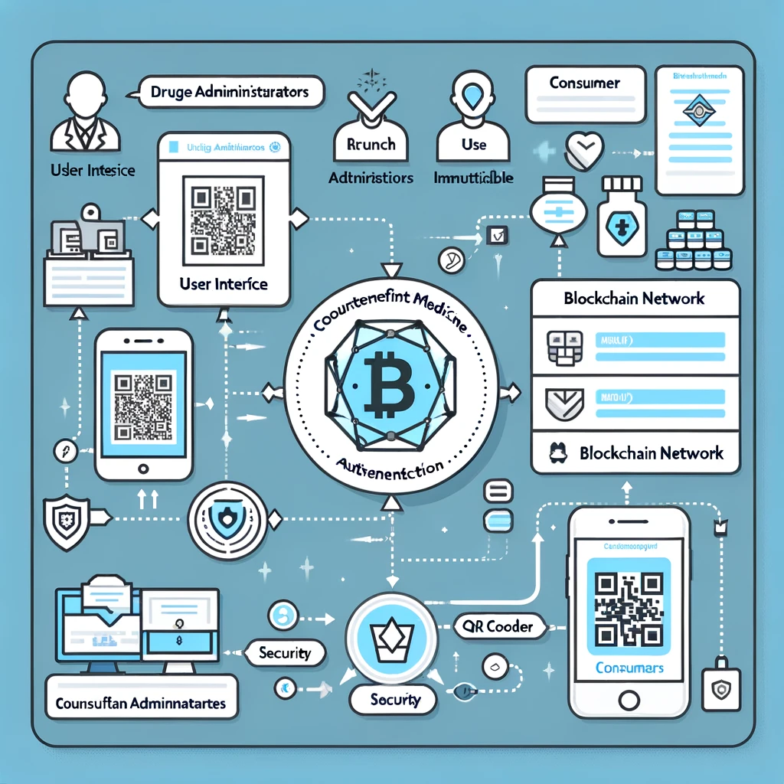

1. **User Interface with Drug Administrator**: This represents the interface through which drug administrators interact with the system. Drug administrators use this interface to input detailed information about medicines, including names, compositions, manufacturers, distributors, batch numbers, expiry dates, and pricing. This interface is designed to be user-friendly, ensuring that administrators can efficiently manage the data required for authenticating medicines.
2. **Blockchain Network with Security**: At the heart of the system is the blockchain network, symbolized by a security icon, indicating the high level of data integrity and security provided by blockchain technology. This network serves as a central repository for all data related to medicines, transactions, and verifications. The blockchain ensures that once information is entered (e.g., medicine details by drug administrators), it becomes immutable and tamper-proof, guaranteeing the authenticity and traceability of medicines across the supply chain.
3. **QR Code Scanner with Consumer**: This component symbolizes the tool used by consumers to verify the authenticity of medicines. Consumers can scan QR codes on medicine packages using their smartphones or dedicated devices. Each QR code contains encrypted data about the medicine, such as its origin, batch number, and expiry date. Upon scanning, this information is retrieved from the blockchain network, allowing consumers to instantly verify whether a medicine is authentic and safe to use.

**FLOW CHART**

**The diagram visually represents the following steps:**

1. **Start:** The beginning of the process.
2. **Drug Administrator Logs In:** The administrator accesses the system.
3. **Register/Update Medicine Details:** Medicines are registered or updated in the system.
4. **Generate QR Code:** A QR code for the medicine is generated.
5. **Record Details on Blockchain:** The medicine details are recorded on the blockchain.
6. **Medicine Packaged with QR Code:** The QR code is attached to the medicine packaging.
7. **Customer Scans QR Code:** The customer scans the QR code to verify the medicine.
8. **Verify Medicine Authenticity:** The system verifies the authenticity of the medicine.
9. **End:** The end of the process.

**E-R DIAGRAM**

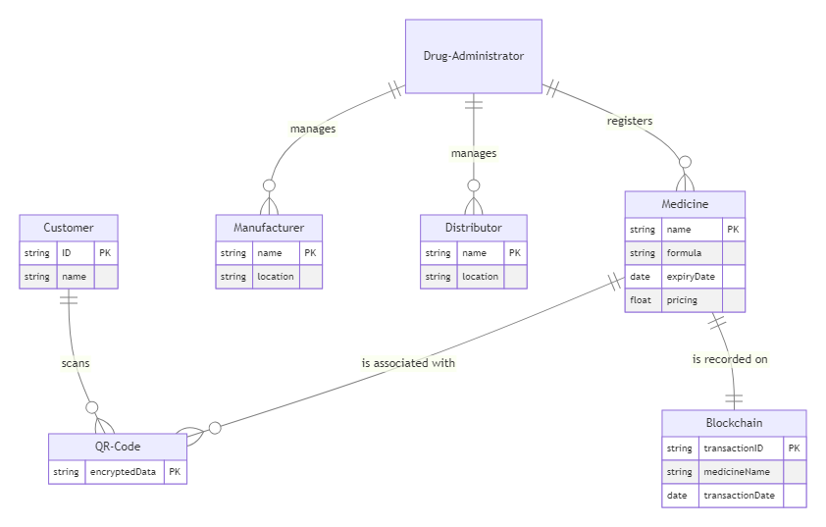

**DATA DICTIONARY**

**Entities and Their Attributes:**

1. **Drug Administrator**
   * This entity represents the administrators who have the authority to register medicines, manufacturers, and distributors in the system. It does not have detailed attributes in this diagram, emphasizing its role rather than its properties.
2. **Medicine**
   * Attributes include the medicine's name (primary key), formula, expiry date, and pricing. This entity represents the pharmaceutical products registered by the drug administrator.
3. **Manufacturer**
   * Identified by a name (primary key) and location, this entity represents the companies that produce the medicines.
4. **Distributor**
   * Similar to the manufacturer, it is identified by a name (primary key) and location, representing the entities responsible for distributing the medicines to various outlets.
5. **QR Code**
   * Contains encrypted data (primary key) associated with a specific medicine. This QR code is used for verifying the authenticity of the medicine by customers.
6. **Blockchain**
   * Represents the blockchain ledger with attributes like transactionID (primary key), medicineName, and transactionDate. It records every detail entered by the drug administrator, ensuring data integrity and immutability.
7. **Customer**
   * Identified by an ID (primary key) and name, this entity represents the end-users or consumers who verify the medicines by scanning the QR codes.

**Relationships:**

* **Drug Administrator to Medicine, Manufacturer, and Distributor**: These one-to-many relationships indicate that a single drug administrator can register multiple medicines, manufacturers, and distributors in the system.
* **Medicine to QR Code**: This one-to-many relationship shows that each medicine can have associated QR codes, which contain encrypted information about the medicine.
* **Medicine to Blockchain**: A one-to-one relationship indicating that each medicine's details are recorded once on the blockchain. This relationship ensures that the information about each medicine is securely stored and immutable.
* **Customer to QR Code**: This one-to-many relationship allows customers to scan multiple QR codes to verify the authenticity of medicines.

**SYSTEM REQUIREMENTS**

HARDWARE REQUIREMENTS

|  |  |  |
| --- | --- | --- |
| MINIMUM (Required for Execution) | | MY SYSTEM (Development) |
| System | Pentium IV 2.2 GHz | i3 Processor 5th Gen |
| Hard Disk | 20 Gb | 500 Gb |
| Ram | 1 Gb | 4 Gb |

SOFTWARE REQUIREMENTS

|  |  |
| --- | --- |
| Operating System | Windows 10/11 |
| Development Software | Python 3.10 |
| Programming Language | Python |
| Integrated Development Environment (IDE) | Visual Studio Code |
| Front End Technologies | HTML5, CSS3, Java Script |
| Back End Technologies or Framework | Django |
| Database Language | SQL |
| Database (RDBMS) | MySQL |
| Database Software | WAMP or XAMPP Server |
| Web Server or Deployment Server | Django Application Development Server, Ethereum |
| Design/Modelling | Rational Rose |

**CONCLUSION**

The **Blockchain-Based Counterfeit Medicine Authentication System** represents a significant leap forward in addressing the critical issue of counterfeit medicines within the pharmaceutical supply chain. By leveraging the inherent strengths of blockchain technology—its immutability, transparency, and decentralized nature—this project introduces a robust framework for ensuring the authenticity and traceability of medicines from production to consumption. The innovative use of encrypted QR codes for product verification further enhances the system's capability to provide end-users with a simple yet effective tool for confirming the authenticity of their medications.

This project not only addresses the pressing challenges posed by counterfeit drugs but also sets a new standard for operational efficiency and global standardization in pharmaceutical safety. The adoption of such a system could dramatically reduce the prevalence of counterfeit medicines, thereby protecting public health, restoring confidence in the pharmaceutical industry, and ensuring the integrity of the global supply chain.

**REFERENCES**

[1] K. Toyoda, P. T. Mathiopoulos, I. Sasase and T. Ohtsuki, "A Novel Blockchain-Based Product Ownership Management System (POMS) for Anti-Counterfeits in the Post Supply Chain," in IEEE Access, vol. 5, pp. 17465-17477, 2017, doi: 10.1109/ACCESS.2017.2720760.

[2] Feng Tian, "A supply chain traceability system for food safety based on HACCP, blockchain & Internet of things," 2017 International Conference on Service Systems and Service Management, Dalian, 2017, pp. 1-6, doi: 10.1109/ICSSSM.2017.7996119.

[3] Z. Li, H. Wu, B. King, Z. Ben Miled, J. Wassick and J. Tazelaar, "On the Integration of Event-Based and Transaction-Based Architectures for Supply Chains," 2017 IEEE 37th International Conference on Distributed Computing Systems Workshops (ICDCSW), Atlanta, GA, 2017, pp. 376-382, doi: 10.1109/ICDCSW.2017.51.

[4] T. Bocek, B. B. Rodrigues, T. Strasser, B. Stiller, “Blockchains every- where - a use-case of blockchains in the pharma supply-chain”, in IEEE IFIP/IEEE Symposium on Integrated Network and Service Management (IM), May. 2017, pp. 772-777.

[5] M. Mettler, “Blockchain technology in healthcare: The revolution starts here”, in IEEE 18th International Conference one-Health Networking, Applications and Services (Healthcom), Sep. 2016, pp. 1-3.

[6] J. Kurki, “Benefits and guidelines for utilizing blockchain technology in pharmaceutical supply chains: case Bayer Pharmaceuticals”, Bachelor thesis, Aalto University, 2016.

[7] Ethereum. Available: <https://www.ethereum.org> [8] T. T. A. Dinh, R. Liu, M. Zhang, G. Chen, B. C. Ooi and J. Wang, "Untangling Blockchain: A Data Processing View of Blockchain Systems," in IEEE Transactions on Knowledge and Data Engineering, vol. 30, no. 7, pp. 1366-1385, 1 July 2018, doi: 10.1109/TKDE.2017.2781227.

[9] Pahlavan K., Li X., Ylianttila M., Chana R., Latva-aho M. (2000) An Overview of Wireless Indoor Geolocation Techniques and Systems. In: Omidyar C.G. (eds) Mobile and Wireless Communications Networks. MWCN 2000. Lecture Notes in Computer Science, vol 1818. Springer, Berlin, Heidelberg. https://doi.org/10.1007/3-540-45494-2_1

[10] S. Maria Celestin Vigila and K. Muneeswaran, "Elliptic curve based key generation for symmetric encryption," 2011 International Conference on Signal Processing, Communication, Computing and Networking Technologies, Thuckafay, 2011, pp. 824-829, doi:10.1109/ICSCCN.2011.6024664.

[11] qrious. Available: <https://github.com/neocotic/qrious>

[12] H. H. Cheung and S. H. Choi, “Implementation issues in RFID-based anti-counterfeiting ystems,” Comput. Ind., vol. 62, no. 7, pp. 708–718, 2011.

[13] SHA 256. Available: <https://github.com/feross/simple-sha256> [14] Paik, Michael, Ashlesh Sharma, Arthur Meacham, Giulio Quarta, Philip Smith, John Trahanas, Brian Levine, Mary Ann Hopkins, Barbara Rapchak, and Lakshminarayanan Subramanian. ” The case for Smart-Track.” In Information and Communication Technologies and Development (ICTD), 2009 International Conference on, pp. 458-467. IEEE,2009.

[15] E. Engineering and C. Science, “Reliable Identification of Counterfeit Medicine Using Camera Equipped Mobile Phones Saif ur Rehman, Raihan Ur Rasool, M. Sohaib Ayub, Saeed Ullah, Aatif Kamal, Qasim M. Rajpoot, and Zahid Anwar,” pp. 273–279.

[16] Sylim P, Liu F, Marcelo A, Fontelo P. Blockchain Technology for Detecting Falsified and Substandard Drugs in Distribution: Pharmaceutical Supply Chain Intervention. JMIR Res Protoc. 2018;7(9):e10163. Published 2018 Sep 13. doi:10.2196/10163.

[17] Feng Tian, "An agri-food supply chain traceability system for China based on RFID & blockchain technology," 2016 13th International Conference on Service Systems and Service Management (ICSSSM), Kunming, 2016, pp. 1-6, doi:10.1109/ICSSSM.2016.7538424.

[18] Pilkington, M. (n.d.). Blockchain technology: principles and applications. Research Handbook on Digital Transformations, 225– 253. doi:10.4337/9781784717766.00019.

[19] Nofer, M., Gomber, P., Hinz, O., & Schiereck, D. (2017). Blockchain. Business & Information Systems Engineering, 59(3), 183–187. doi:10.1007/s12599-017-0467-3.

[20] Mirkin, M., Ji, Y., Pang, J., Klages-Mundt, A., Eyal, I. and Juels, A., 2020, October. BDoS: Blockchain Denial-of-Service. In Proceedings of the 2020 ACM SIGSAC conference on Computer and Communications Security (pp. 601-619).

[21] Shen, M., Tang, X., Zhu, L., Du, X., &Guizani, M. (2019). Privacy- Preserving Support Vector Machine Training over Blockchain-Based Encrypted IoT Data in Smart Cities. IEEE Internet of Things Journal, 1–1. doi:10.1109/jiot.2019.2901840.